CG2111A Engineering Principles and Practice II
Studio 4: Pulse Width Modulation (PWM) Programming
Answer Book

Choose ONE person to submit this report in PDF format, and name the report using the submitter's student number. For example, if the submitter's student number is A1495832X, then the PDF file should be called A1495832X.pdf.

Please submit ONE REPORT per sub-team.

Student Information
Submitting Student Name: Leon Matthew Wei | Submitting Student ID: A0320416U
Student 2 Name: Li Yi An | Student 2 ID: A0334942B

Answers

Please answer all questions below:

Q1: [3 marks]
*PWM Waveform Analysis* Take a screenshot of the waveform in your software and include it in your report. You must take measurements on your waveform as the format shown in Section 1.3. a) Measure the period of your waveform b) Measure the pulse width (ON time) of your waveform Note down the following parameters in 2 decimal places from the waveform: (a) Period (b) Pulse Width;
Answer:
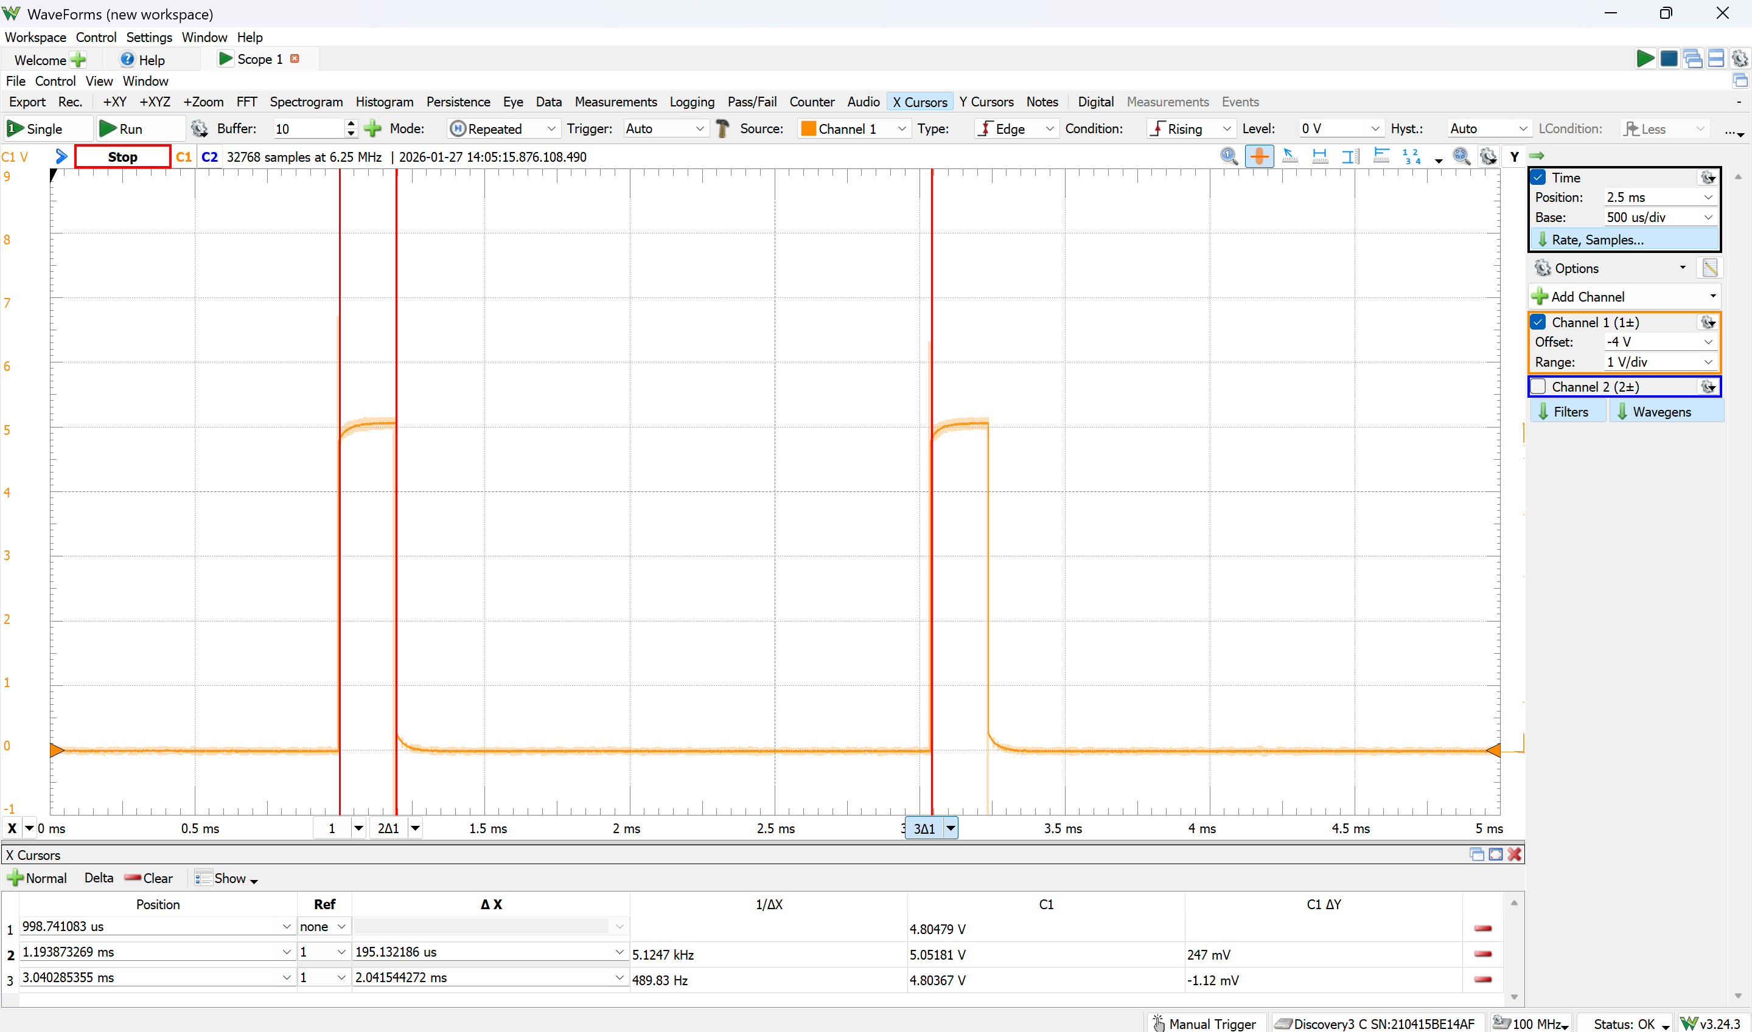
$$Period of waveform \left(s\right)=2.04×{10}^{-3}(s)$$
$$Pulse width, ON Time \left(s\right)=1.95×{10}^{-4}(s)$$

Q2: [1 marks]
Calculate the Duty Cycle based on the formula given earlier.
Answer:
$$Duty Cycle \left(\%\right)=\frac{ON Time \left(s\right)}{Period \left(s\right)}×100\%$$
$$Duty Cycle \left(\%\right)=\frac{1.9513×{10}^{-4}}{2.0415×{10}^{-3}}×100\%=9.56 (\%)$$
Q3: [1 marks]
Explain: why don't we need to write an ISR to generate a PWM signal?
Answer:
The PWM signal is generated by a timer, which is independent from interrupts thus ISR is not needed.

Q4: [3 marks]
*Program a complement waveform* You are now tasked to generate a complement of the current waveform (HIGH becomes LOW and LOW becomes HIGH). Provide the code change that is needed to do this WITHOUT changing the OCR0A register value. State the changes that you made in the code and provide an explanation on how your changes achieve the desired outcome.
Answer:
TCCR0A = 0b11000001; // Set OCOM0A to 11 and WGM to 01

Explanation:
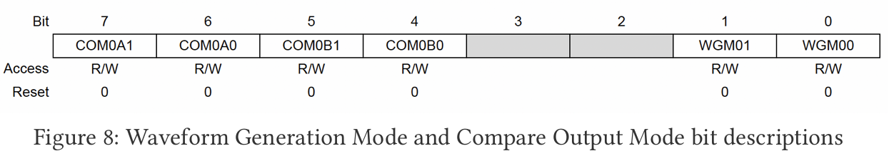
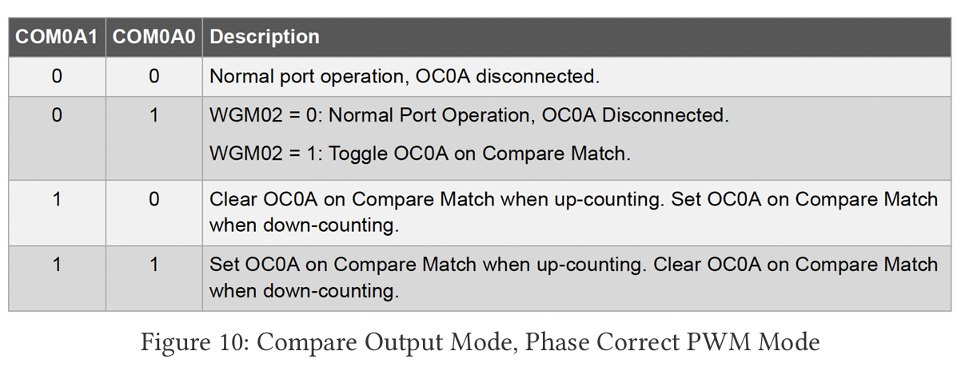
Current configuration: COM0A1 = 1, COM0A0 = 0
Current output: When TCNT0 counts up from 0 to OCR0A, OC0A is cleared (set to LOW)
When TCNT0 counts down from 255 to OCR0A, OC0A is set (set to HIGH)
New configuration: COM0A1 = 1, COM0A0 = 1
New output: When TCNT0 counts up from 0 to OCR0A, OC0A is set (set to HIGH)
When TCNT0 counts down from 255 to OCR0A, OC0A is cleared (set to LOW)
Therefore, instead of TCCR0A = 0b10000001, use TCCR0A = 0b01000001

Q5: [2 marks]
Screenshot and include a copy of the waveform in your report. You must take measurements on your waveform as the format shown in Section 1.3.
Answer:
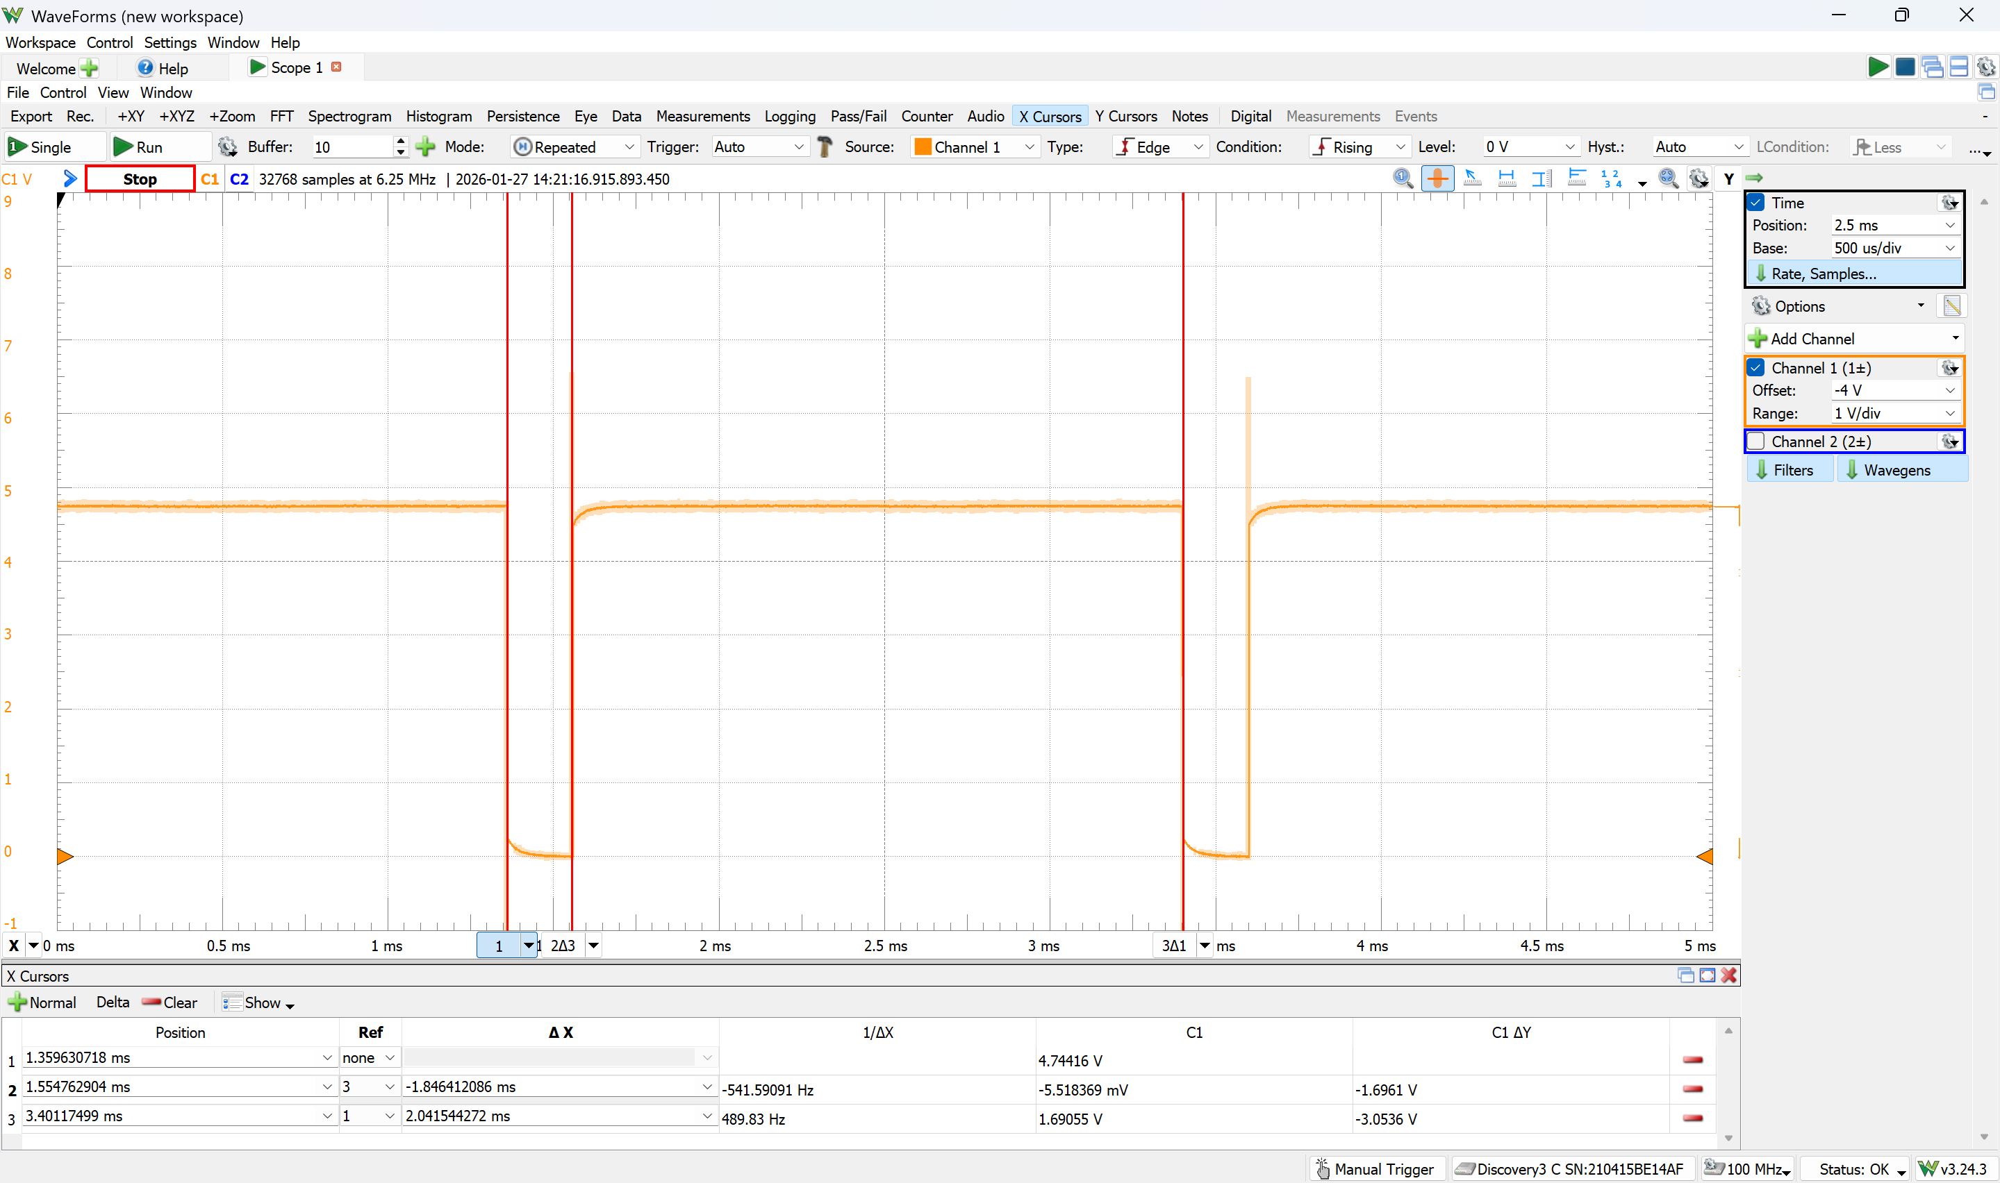
$$Period of waveform \left(s\right)=2.04×{10}^{-3}(s)$$
$$Pulse width, ON Time \left(s\right)=1.85×{10}^{-3}(s)$$
$$Duty Cycle \left(\%\right)=\frac{1.8464×{10}^{-3}}{2.0415×{10}^{-3}}×100\%=90.44 \left(\%\right)$$

Q6: [3 marks]
*Fade In / Fade-Out Effect* Implement a Fade In / Fade Out effect for the LED. That is, it should gradually become dimmer until it is unlit, and then gradually become brighter until it is at full brightness, and then repeat the process continually You must ONLY change the code in the ISR. Other parts of the code must NOT be changed, but you are free to declare additional variables in your code. Include your ISR code in the report and state the declaration of any additional variables.
Answer:

Q7: [2 marks]
This fading effect is very fast, so lets slow it down a little. Reduce the speed of the fading effect. Provide your code snippet for this in your report. Hint: you only need to change the value in one register for this effect.
Answer:

Q8: [3 marks]
*Which Timer?* Explain why an 8-bit Timer/Counter cannot generate a 50 Hz PWM signal. In your answer, calculate the closest achievable frequencies using the 8-bit Timer/Counter and show that they deviate significantly from 50 Hz, either being too high or too low.
Answer:
$$f_{OCnxPCPWM}=\frac{16×{10}^{6}}{N×2×255}=50Hz$$
$$N=627.45$$
Thus, the closest available N values are either N = 256 or N = 1024
However, when N = 256, $f_{OCnxPCPWM}=\frac{16×{10}^{6}}{256×2×255}=122.55Hz$
and when N = 1024, $f_{OCnxPCPWM}=\frac{16×{10}^{6}}{1024×2×255}=30.63Hz$
Since 122.55Hz and 30.63Hz are too different from the desired frequency of 50Hz, an 8-bit Timer is not suitable.

Q9: [5 marks]
Use a 16-bit timer (Timer 1) to generate a 50 Hz waveform. Assign the appropriate values to the registers in the setup() function. Refer to the datasheet to determine the correct register values. a) Attach the waveform screenshot in your lab report. b) Paste your code in your lab report.
Answer:

Q10: [4 marks]
The servo motor can rotate from 0° to 180°. Modify your code to make the servo continuously sweep from 0° to 180° and back to 0° in a smooth motion. Ensure a gradual transition by adjusting the pulse width incrementally. You are allowed to use the delay function for smoothness, but not to actually generate the PWM pulses themselves. a) Include your code in your lab report. b) Show your servo motor behavior to your TA.
Answer:

